# Completed Prototype

<https://miro.com/app/board/uXjVNU_AOdc=/>

# Goal: Need to draw the following

* 1. Frame (showing the keyboard/feature)
* 2. Transition (an arrow(s) from one frame to another, include description of what needs to be done for that interaction, e.g. click)
  + Note: Please only show the arrow and some description above/below the arrow and that’s it (do not directly draw on the frame b/c that might block some features)

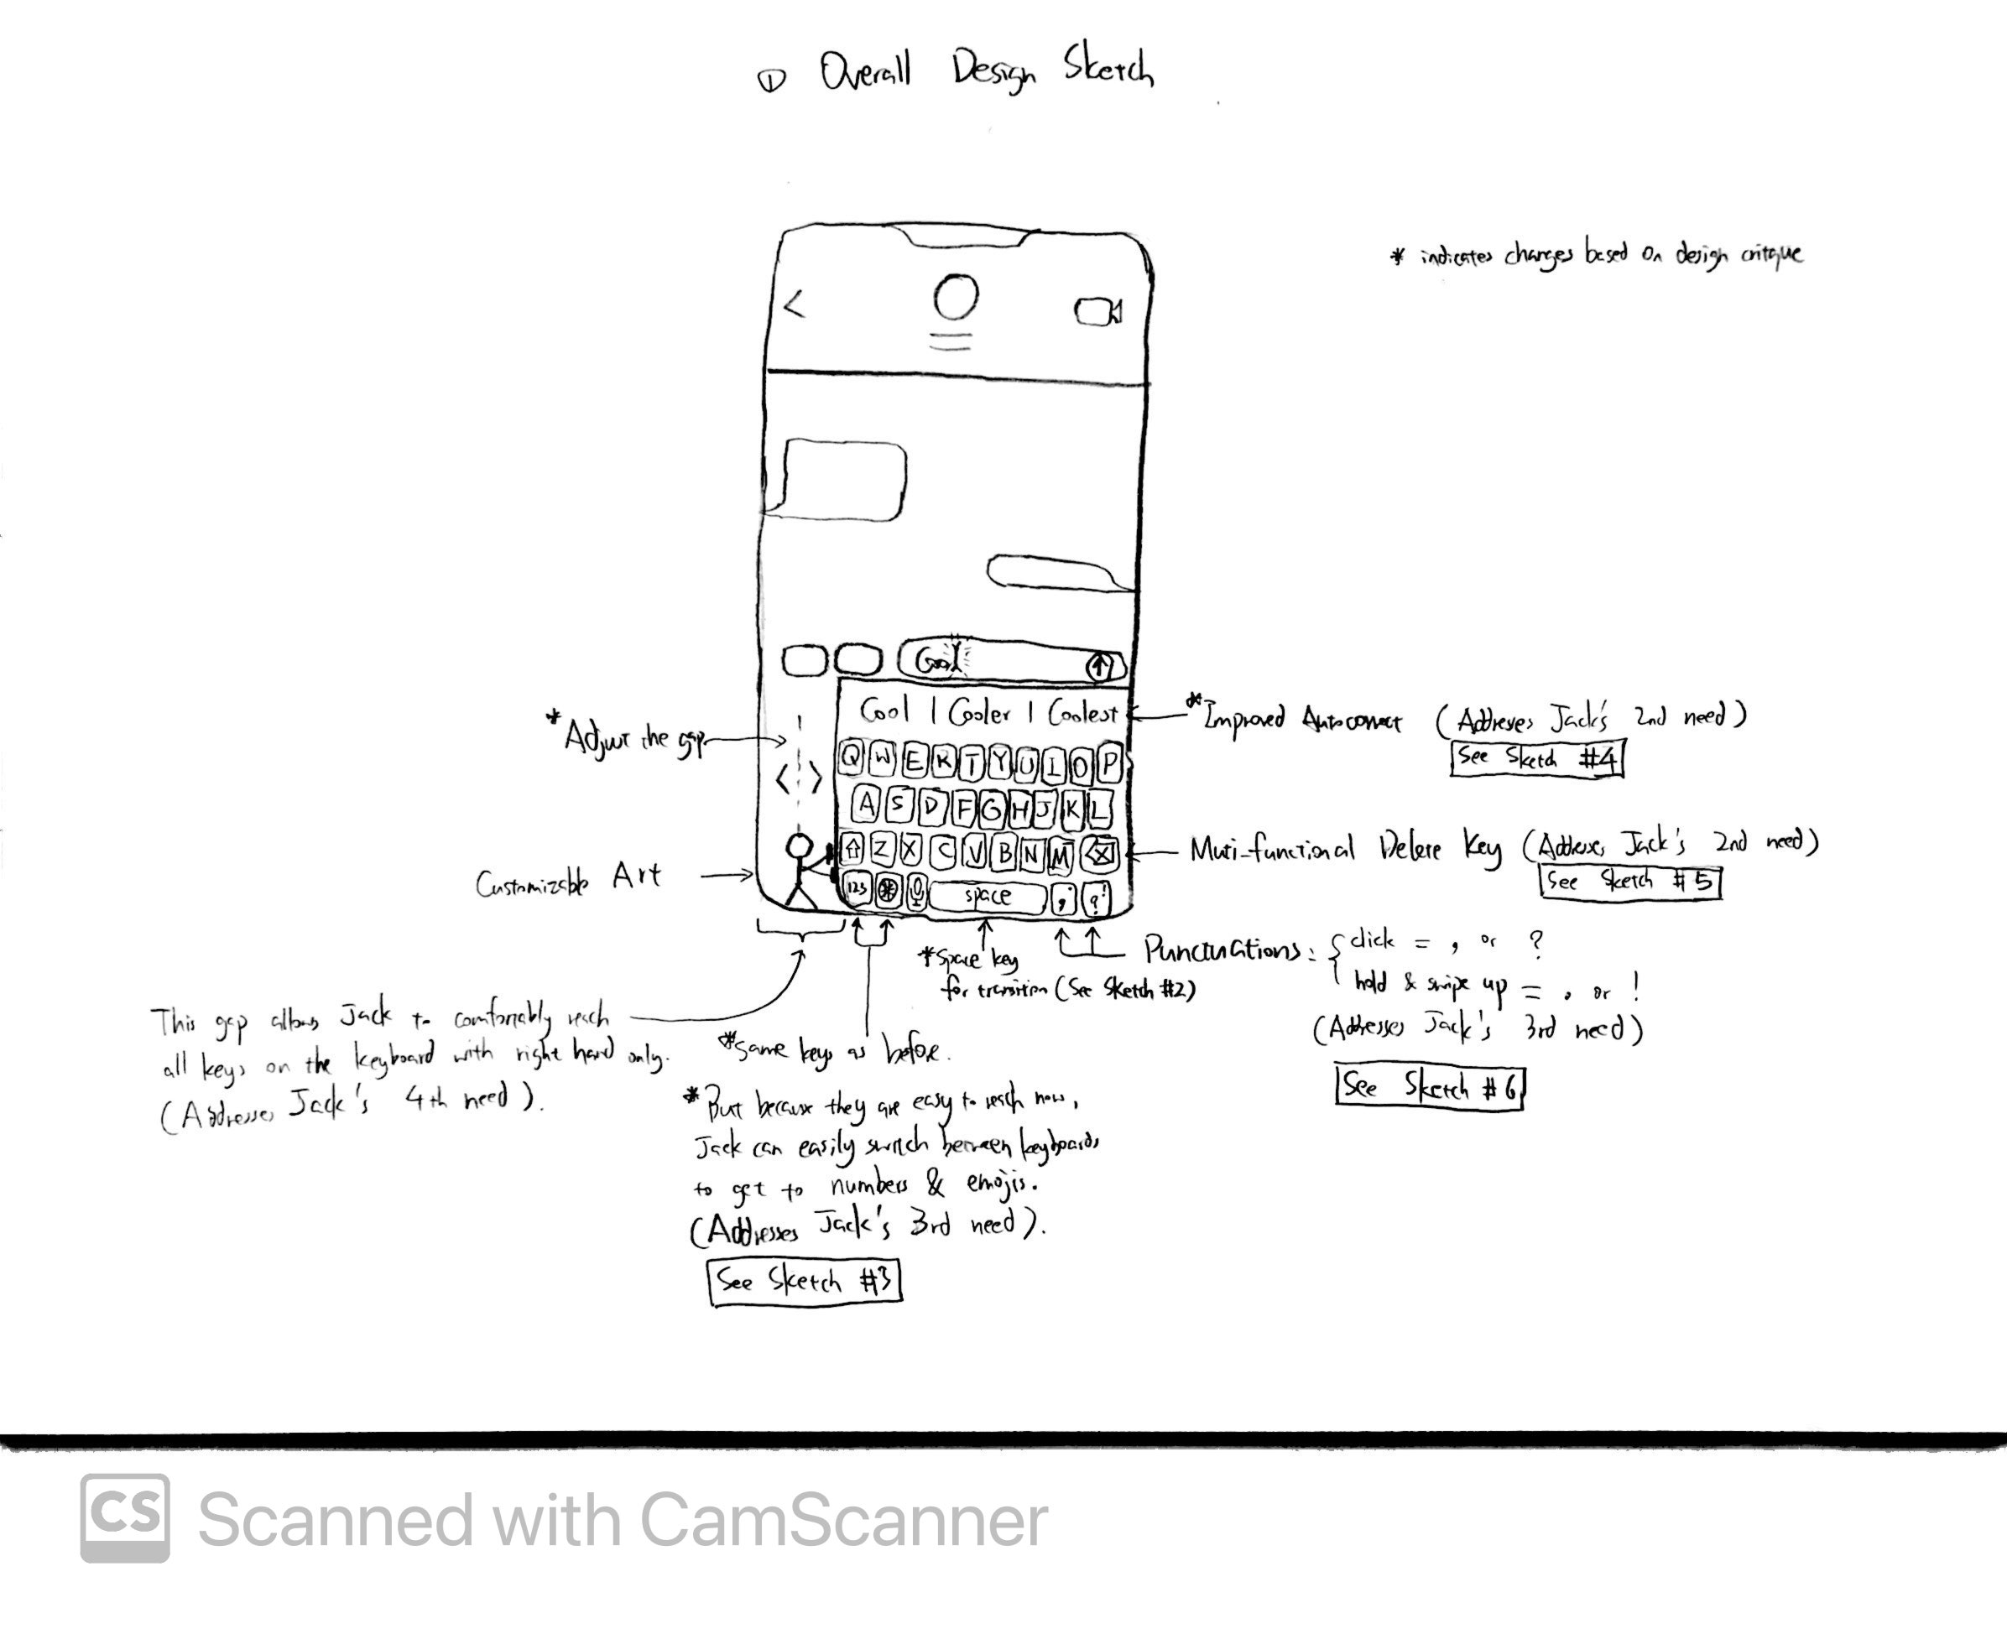

# Instructions

When drawing the final paper prototype

* Download the [Final Paper Prototype Template](https://docs.google.com/document/d/1gFW1CYs27RQzCkghzt6ey3xEMKGdN_Ro1n9eGWu0CHk/edit?usp=sharing) and draw it in the iPhone frame
* Background is always the text messages (iMessage app)
  + need to keep consistency
* Show transition from one frame to another frame using arrows (use words above/below the arrow to describe what interaction caused which transition)
* Sketches (for reference) are located in [Final Sketches & Storyboards](https://docs.google.com/document/d/1f3glr4zcB6Cb9gnNvxALwbJtwwtXOolHHBRwPjrqcjQ/edit?usp=sharing), i need to fix some things in them but the gist is there

# Main Frames

1. Two-handed keyboard
   * Draw the current/existing keyboard on iPhone (with same background as Sketch 1)
   * Transition: swipe right on space key to transition to Frame 2 (next bullet point)
     + See **Sketch 2** for reference
2. One-handed keyboard (our design)
   * Basically just redraw (copy & paste) **Sketch 1** inside the iPhone frame
   * Transition: swipe left → go back to Frame 1 (previous bullet point)
   * Transition: hold down the edge of the keyboard and slide right to adjust how much the keyboard is squished → go to Frame 3
   * Transition: click on some letter keys on the keyboard → go to Frame 4

# Frame showing adjusting keyboard width (squish)

See **Sketch 3** for reference

1. Adjusted One-handed keyboard
   * Basically just redraw Frame 2 but have the width of the keyboard to be even smaller (the keys will be more squished towards the right)
   * This shows the user can squish the keyboard further towards right
   * Transition: hold down the edge of the keyboard and slide left → go back to Frame 2

# Frame showing comma

See Sketch 6

1. Typed Word
   * Shows a word being entered in the text box with everything else exactly same as Frame 2
     + See left panel in Sketch 6
     + The word in the textbox is “Cool”
   * Transition: click on comma key → go to Frame 5
2. Comma
   * Shows a comma being entered in the text box with everything else exactly same as Frame 2
     + See left panel in Sketch 6
     + The text in the textbox now is “Cool**,**”
   * Transition: click any letter key → go to Frame 6

# Frames showing improved autocorrect & delete

See **Sketch 4 & 5** for reference

1. Typo
   * Shows a typo in the text box with *everything else* exactly same as Frame 2
     + See leftmost panel in Sketch 4
     + The text box here should written as “Cool, good lyck”
   * Transition: click on the typo (lyck) → go to Frame 7
   * Transition: hold down delete key & swipe left → go to Frame 9
2. Suggested word list
   * Shows a list of 9 words and a delete key
     + See middle panel in Sketch 4
   * Transition: *suppose* user finds the right word & clicks on it → go to Frame 8
   * Transition: *suppose* user did not find the right word & click delete → go to Frame 9
3. Successfully changed typo using autocorrect
   * Shows the typo (lyck) being corrected (kick) & keyboard changes back to normal (i.e. keyboard now looks the same as Frame 2 but the words in the textbox should be “Cool, good kick”)
     + See top right panel in Sketch 4
   * Transition: user hold down exclamation mark key → go to Frame 10
4. Alternative to autocorrect: manual delete
   * The typo is deleted
     + Textbox shows “Cool, good”
     + Keyboard goes back to the same as Frame 2
   * Transition: click any letter key → go to Frame 8
   * Alternative Transition: click any letter key → go to Frame 6

# Frames showing Exclamation mark

See Sketch 6

1. Exclamation mark
   * Shows exclamation mark hovered on top of the punctuation key with everything else exactly same as Frame 8
     + The text in text box says “Cool, good kick”
     + See right panel in Sketch 6
   * Transition: use slides up → go to Frame 11
2. Finish sentence
   * Shows the completed sentence in the text box with everything else exactly same as Frame 2
     + The text says “Cool, good kick!” (with exclamation mark now)
     + See right panel in Sketch 6
   * Transition: clicks on send key → go to Frame 2

# One-handed numbers & emojis keyboard

1. One-handed numbers keyboard
   * Shows exact same numbers/punctuations keyboard on the iPhone, but just squished to the right like Frame 2
2. One-handed emojis keyboard
   * Shows exact same emojis keyboard on the iPhone, but just squished to the right like Frame 2